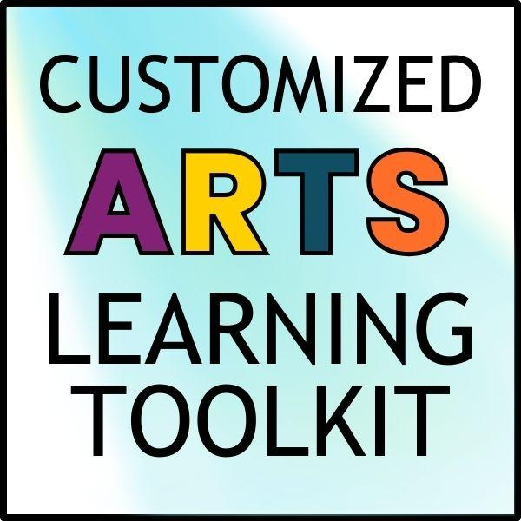

Customized Arts Learning Quality Reflection Tool
Reflect on the quality of the exploration you are preparing for your students. Reflection questions may include:

Quality | Reflection Question(s) | Narrative Evidence
Accuracy | Is the information/resource factually correct and up-to-date? Can it be supported by evidence and credible resources?
Appropriateness | Is the information/resource appropriate, clear, and understandable for the age level it is intended for?
Engagement | Is the information/resource engaging and interactive? Does it enhance or stimulate curiosity?
Depth | Do the materials/experience have layers to be explored? Does it bear repeated interaction/thought?
Accessibility | - How is the material/experience accessible and flexible for all students? What instructional supports are included for  - multilingual learners  - at-risk students  - students with visible and non-visible disabilities, and  - all students, regardless of demographic markers  - Based on current and confirmed research, how is this material/experience developmentally appropriate and/or beneficial to this group of students?  - What additional support is needed to help all students succeed?

Alignment | - How does this instructional material/experience align to your state’s arts standards?  - How does the material/experience develop artistically literate individuals?  - What opportunities are there for cross-curricular collaboration(s) in other arts subjects or content areas?
Authenticity | - How does this material/experience promote student participation and communication in visual and performing arts communities at home and around the world?  - How does the material/experience promote interaction and intercultural competence with visual and performing arts communities?  - How does the material/experience show a variety of perspectives?  - How does the material/experience include visual and/or performing artists with underrepresented/underserved communities and lift up their discoveries or expertise?  - How does this material/experience relate to the experiences and interests of students in your local community or state?
Teacher Role | - What supplemental information or supports are needed to ensure the exploration of this material/experience is high quality, given my findings in this tool?  - How will I scaffold learning and prepare for the experience or use of this material?  - How will students exit the experience? How will learning build after?  - What support/resources do I need?

