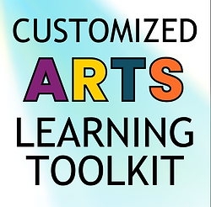 | Experience 3Es Planning Sheet  Engage, Explore, Express
caltoolkit.org | Framework Step | My Resources | Lesson Plan Steps
E  N  G  A  G  E | Notice: Present a work and invite students to make objective observations.
 | Share: Invite students to share what they think about this work, the culture from which it comes, and/or the art form, techniques used, etc.
 | Wonder: Students challenge assumptions and develop questions to inform future learning.
E  X  P  L  O  R  E | Explore: Students are involved in a cultural experience with a cultural insider.
E  X  P  R  E  S  S | Debrief: Students develop and express new understanding based on their experience.
 | Respond: Students will integrate what they have learned by engaging in artistic processes (creating, responding, connecting).
 | Reflect: As students create, perform/present, or respond, they articulate how the cultural experience informed their work.
 |  |  | 

